In keno the casino, or game machine, will draw 20 numbers out of 70, without replacement. Before this happens the player may pick 1 to 11 numbers. It is then called Keno 11. You can play on different slots, slot 11 means you need to get 11 right, slot 10 means 10 right and so on. The highest slot is 11 and the one that yields highest win.

A "catch" is a number the player picked and was drawn by the casino. A "miss" is a number of the player picked but was not drawn by the casino. The player is paid according to the number of picks made and catches.

|  |  |
| --- | --- |
| Number of catches | The player is paid in SEK=0.11USD |
| 11 | 5,000,000 |
| 10 | 125,000 |
| 9 | 3000 |
| 8 | 300 |
| 7 | 30 |
| 6 | 10 |
| 5 | 5 |
| 4 | 0 |
| 3 | 0 |
| 2 | 0 |
| 1 | 0 |
| 0 | 0 |

Each draw is independent event so probability of any number coming up in the next draw is the same. Relative frequency of any number showing up will settle down and even out in the long run. The idea of long run can be difficult to grasp since it is infinitely long.

The relative frequency may vary between the rounds and might invite to speculations that sequence of events compensate in the short run by throwing a number that hasn’t shown up for a while. Probability of any outcome for two independent events in another trail is always the same no matter what happened in other trials.

Relative frequency after 10 runs and after 1000 runs.

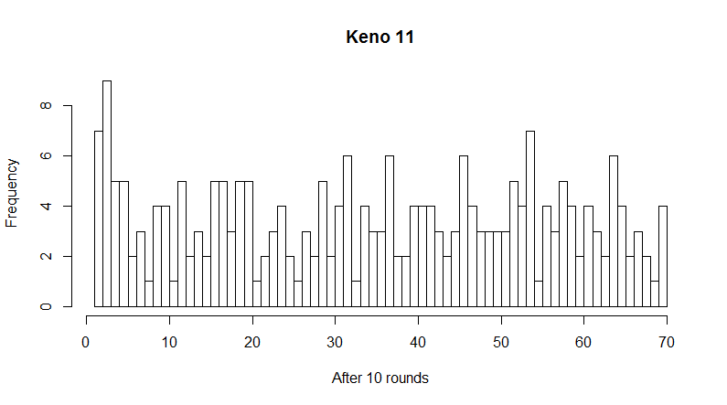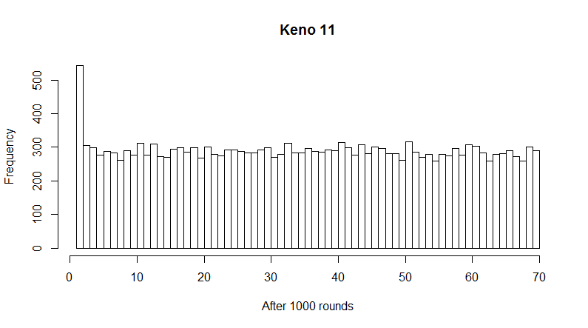

The odds of winning, having 11 catches, are pretty lousy and can be calculated by P(X) = combine(20,11)/combine(70,11) is 0.00000007762116. Number of ways 11 numbers can be chosen from 20 divided by number of ways 11 numbers can be chosen from 70. Since 10 catches also generates prize one number comes from the losing urn.

P(X) = C(20,k)*C(50,11-k)/C(70,11) where k is number of catches in Keno 11

Distribution of probability

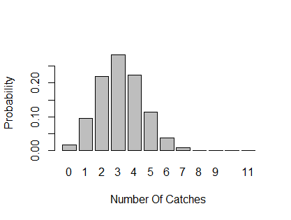

As you can see chances of winning any money worth mentioning are very poor.